===================
PRACTICE
Multi-bar chart: without timeline
The graph below shows the hours of teaching per year done by each teacher in four different countries in 2001

INCLUDEPICTURE "https://ielts.pasal.edu.vn/upload/files/de_thi_ielts_2023_3.png" \* MERGEFORMATINET INCLUDEPICTURE "https://ielts.pasal.edu.vn/upload/files/de_thi_ielts_2023_3.png" \* MERGEFORMATINET INCLUDEPICTURE "https://ielts.pasal.edu.vn/upload/files/de_thi_ielts_2023_3.png" \* MERGEFORMATINET 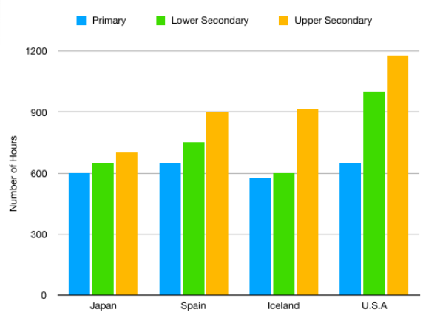

OUTLINE

OVERVIEW:

BODY:

The chart supplies data regarding teaching hour numbers each year of teacher / teachers in four variety / diverse / various countries in 2001.
Overall, the number of teaching hours in the USA took the lion's share in all most kinds / almost kinds / almost không đứng trước danh từ vì nó là trạng từ ,, dùng almost all kinds / most of of education , whilst Japan and Iceland quantities hit a trough of teaching hours in primary and secondary school . Additionally , high school became the place to have most of teaching hours in three levels . / so luong gio day cua GV cap ba vuot troi cac cap con lai trong suot nam 2001/ the teaching hour number of high school levels surpassed those of the others throughout 2001
As the chart reveals , so luong gio day?? American teaching hour / the American teaching hour quantity of secondary and high school surpassed that of these other countries / hit a pick of, hitting a peak of around / nearly 1000 and 1200 respectively . Beside that , con so do cua the teaching hour number of American primary school / this number of American primary school reached / reach không có giới từ approximately 650 , as high as that of Spain . By contrast , Japan and Iceland hour numbers / Japanese and Iceland ‘s numbers of primary and secondary school ranked at the bottom of the list , with these figures of both countries registered from around / Closely 550 to 600 / with 550 for the former and 600 for the latter . Plus / meanwhile, the hour numbers of high school in Japan amounted / japanese figure in high school amounted to nearly 700 , standing at the last position on the list .
As for teaching hour number of Spain / as for spanish figure , it accounted for 900 hours The number of primary school acounted/ accounted for 900 hours , as high as that of / reaching similar level of Iceland / reaching resembling to that of Iceland . In addition , the figure of secondary school reached / comprised around / averagely 700 hours , standing behind that of USA.
220 words 50p
+lengthy writing!
+many repetitions!
BAND SCORE: 4.5

